Cleaver of Truth Ministry
7096 Fort Gay Rd
Fort Gay, WV 25514
Ph. (304) 648-3012
www.Cleaveroftruthmintry.org
________________________________________

February 2011 - Newsletter

Dear Family and Friends,

We thank God for the opportunity to send you another newsletter. God bless you one and all.

Our subject this month is: It Is Possible to Get Well and Be Disease Free

That Sign!

If you own a Bible, you possess the most amazing and unique book in the entire world! Through the centuries, people have tried to destroy the Bible, but with no success. It continues to be the world's best seller. Voltaire, a French unbeliever, predicted once that within one hundred years, the Bible would be so out of date that no one would print it any longer. One hundred years later, the building in which he made this statement was a Bible distribution center!
The following is based on a true story of the power of a single verse from the Bible to change a life.
"I'm goin' out," the old farmer told his wife one afternoon. "Where are you going, Dear?" she asked.
"Down to the gravel pit with the tractor. I need a little more gravel on this driveway to get rid of the mud." Jake climbed onto the tractor and headed down the driveway. The abandoned limestone quarry made a great source for the entire community so everyone took what gravel they needed. For Jake it was especially convenient that the gravel was not far from the house.
Jake eased onto the highway and headed south to the familiar turn. Then he saw it…… that sign in front of the church. He knew what it said, "Be sure your sin will find you out (Numbers 32:23)" in big, bold letters.

"I won't listen to their preachin’ nonsense," he told himself, "and I won't let them come talk me into any of that ignorant religion. So how come they can get away with pollutin' the roadside like this? I mean, it's one thing to put up a sign telling who you are, but it's a whole 'nother thing’ usin' public view to preach at folks." The more Jake thought about that sign, the more angry he got.
Just then Jake got an idea. He looked this way and that. No one was in sight. The gravel dump was close by. Who would know if the sign suddenly got 'lost'? Jake wheeled his tractor around and yanked the sign out of the ground with his scoop, post and all. Then he drove quickly down to the gravel pit. He was in luck; no one was around. Jake dumped the sign on the ground and hastily dug a hole next to it. He then scooped up the sign, dumped it into the hole, and covered it with dirt. Jake wheeled the tractor around, looked at the grave, and then smiled. "No one will ever know what happened to that sign," he boasted, feeling very proud of himself. "For the first time in a long time we can ride down that road without getting preached at." Then Jake scooped up his load of gravel and headed for home.
The old farmer carefully spread the gravel on his driveway, then grated it smooth. His wife noticed he seemed a little happier than normal, but she didn't bother asking why. Shortly before dusk, Jake decided he would need a little more gravel so he drove off one last time toward the pit. As he approached the church, he slammed on the brake and yanked off his hat. He couldn't believe his eyes. There was that Bible sign in the same spot, looking brighter and clearer than ever! How could this be? Jake read the sign again. "Be sure your sin will find you out."

The words struck him. He realized that was exactly what had happened. Jake was so dumbfounded that he wheeled around and headed for home.

The next week Jake was with his wife in church and, a few weeks later, he accepted Christ as his Saviour.

Some months later Jake gave a testimony at one of the services.

He told them for the first time his devious plan to bury the sign and about its miraculous reappearance. He told how the message on the sign, turned his heart to God.
When he finished, George who was a church member, stood up and shared this story;

Shortly after Jake had buried the sign, George came to the gravel pit to get a load of gravel for himself. As he drove in, he noticed what looked like a fresh digging. The rocks were wet but there was no hole. George scooped up a load of gravel from that spot, but his blade suddenly struck something. Jumping off his tractor, George brushed away the gravel only to discover the sign from the front yard of his church.

"I wonder how our sign got out here," he asked himself. "Oh, well, It's about time to refresh it a little anyway. The colors are fading and the paint is starting the peel." So George lifted the sign from the gravel, drove it to the church yard, and planted it back in the same spot. He carefully wiped off the sign, got some paints, and repainted the lettering and the border.

Jake and George laughed for joy, for they knew that this was God's way of getting Jake’s attention and making him listen to what the Scripture had to say.

FROM KATIE’S COOKBOOKS

EASY WHEAT ROLLS
2 cups warm water (approximately 110 degrees F
6 Tbsp honey (about 1/3 cup)
2 Tbsp baking yeast
3 cups unbleached flour
2 cups whole wheat flour
1 ½ tsp sea salt
1 cup olive oil (I use the light for bread)

In a large bowl add the water, yeast and honey. Stir gently until most of the yeast has dissolved. Cover bowl with towel and place in a warm area to froth. (usually takes not more that 20 minutes). Stir in the oil and salt. Add flour then stir until it becomes a dough consistency. Then use hands to fold continuously adding more flour until dough is elastic and forms into a good ball. Cover and place in warm area to allow the dough to rise. (Usually takes about an hour). Punch dough and it should fall. Form into rolls or buns and place on a sprayed baking pan. Let rise in warm area for 30 minutes. Bake at 375 for 15 to 20 minutes or until done. Then remove buns or rolls from baking pan onto a cooling rack. Cover with towel until bread is cool. Don’t eat bread for 24 hours to let the yeast die. After bread is completely cooled you may freeze it. Times of Refreshing/Diane Flemons

I think you will enjoy this bread! It’s easy to make and tastes so good! It doesn’t have the harmful ingredients and preservatives that you find in most store bought bread.

Rodney and I are looking forward to Spring when we can start our garden and get all those fresh veggies! There is nothing better than “fresh stuff” from your garden.

Remember God loves you and so do we!

Katie and Rodney

HEALTH NUGGET

Relieve Joint Pain Naturally

Ever since popular COX-2 Inhibiting painkillers were pulled from the market in 2004, people have been searching for safe, effective ways to ease aches and pains. While the risk of cardiovascular effects of prescription nonsteroidal anti-inflammatory drugs (NSAID’s) like Celebrex are greater, aspirin and ibuprofen are not completely safe either. These common over-the-counter pain relievers may increase blood pressure, impair the ability of blood vessels to relax, and even counteract the benefits of some hypertension medications.

These over-the-counter pain relievers, along with others can cause a variety of problems ranging from ulcers, and dangerous stomach bleeding, to liver or kidney failure. (Selected Sources)

“Making the news yesterday was the decision by the FDA to reduce the dosage of "prescribed" pain pills that contain Acetaminophen to have no more than 325MG of the ingredient. Oddly, the amount you'll be able to get over-the-counter via many brands remains at 500MG, at least for now.

The FDA stated that "Overdose from prescription combination products containing acetaminophen account for nearly half of all cases of acetaminophen-related liver failure in the United States, many of which result in liver transplant or death."

So by having reduced the amount available in a pill, they are trying to reduce the potential for overdosing- again this is just with the prescriptions containing acetaminophen. I'm not sure this will help as it still doesn't address the problem completely.

The damage to the liver is thought to be a result of the depletion of the antioxidant called glutathione that is caused by acetaminophen. You should know that antioxidants help fight toxins/free radicals and this fighting is a job performed by your liver.as I often say the liver is the oil filter to your body's engine!” (excerpts from Article submitted by Brenda Adams)

You may want to consider some natural pain-relieving anti-inflammatories instead: (Most of these can be found in your own kitchen).

1. Celery – contains five different COX-2 inhibitors, more than thirty-six anti-inflammatory components and several arthritis-fighting substances. This crunchy veggie also slows aging and lowers blood pressure and cholesterol. (Celery seed is an ingredient in more than 50 anti-inflammatory products in Great Britian.)

2. Ginger – Is well known for digestive complaints and morning sickness. It is even more endowed in COX2 inhibitors and arthritis-and-inflammation-fighting compounds than celery. Ginger’s antioxidant compounds help fight plague buildup in the arteries and improve cholesterol levels.

3. Red Pepper (capsicum or cayenne) can inflict pain to the tongue, but its fiery capsaicin interferes with the transmission of pain impulses elsewhere in the body. It also triggers the release of endorphins, (nature’s own opiates) and contains aspirin-like components. For arthritis you can apply capsaicin cream directly to painful joints four times a day. Be sure to wash hands thoroughly because you don’t want to get it in your eyes!

4. Turmeric (curcumin) relieves aches and pains and is easier on the tummy than aspirin. This tasty yellow spice restricts the the body’s release of COX-2 prostaglandins, which are secreted in response to sources of inflammation and swelling. Turmeric may also help prevent colon cancer. Studies show that 1200 mg of curcumin daily is as effective as corticosteroids, without the side effects. (But don’t use this spice if you have gallbladder problems.)

Natural Pain Remedies

For Arthritis pain in the joints n- Make a tea of the following: Valerian root, peppermint and chamomile. (Use about ½ - 1 tsp of each in a cup of hot water) Let steep for about 10 minutes. (You can experiment on the dosage, more or less to what works best for you)

For extreme pain- (Can help for pain of cancer.) Use Jamaican Dogwood Tincture. (Can probably find this in a health food store, but it is very important to follow directions on the bottle. (Shelem Flemons/Times of Refreshing)

Sage – Combined with Echinacea is as effective as the pain-killer lidocaine in relieving sore throat pain. Also it is a potent breath freshner. Make mouthwash by steeping 1 Tablespoon sage leaves in 1 cup hot water for 5 minutes, strain and gargle as often as needed.

Rosemary - Is a memory enhancer and can also reduce joint pain. Make an ointment by soaking rosemary needles in almond oil for 2 weeks, filter and rub the oil onto sore joints as needed.

Lemon balm – Helps to relieve tension, anxiety and restlessness, increased memory and improved mood. (Had similar results among Alzheimer’s patients.) Make a tea out of the Lemon balm. (Selected Sources)

Beloved, I wish above all things that thou mayest prosper and be in health, even as thy soul prospereth. 3 John 1:2

Be not wise in thine own eyes: fear the LORD, and depart from evil. It shall be health to thy navel, and marrow to thy bones. Honour the LORD with thy substance, and with the firstfruits of all thine increase: So shall thy barns be filled with plenty, and thy presses shall burst out with new wine. Proverbs 3: 7-10

This month we want to wish a very Happy Birthday to one of our Bible Students:

HAPPY BIRTHDAY ALMA LOVEJ0Y!

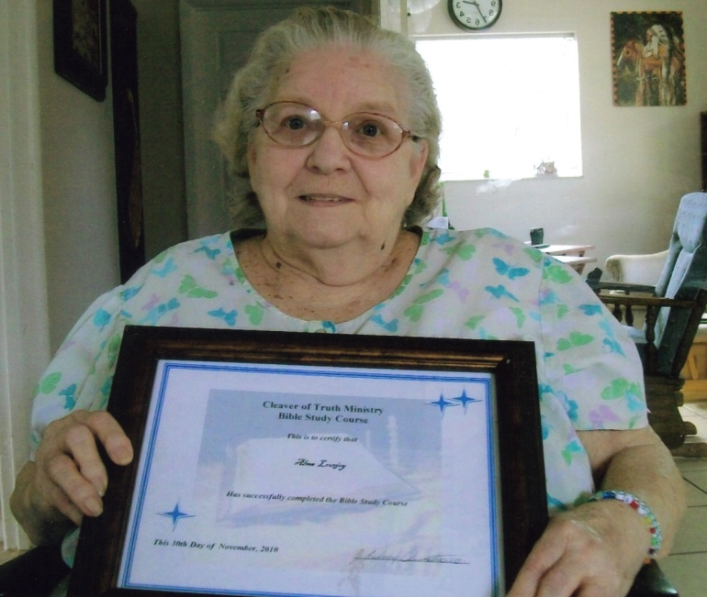
Alma lives in Fort Pierce, Florida. Although she soon will be 86 years old she has completed one Bible Study Course and received her first Bible Certificate. She is now working on another series of lessons dealing with the Book of Daniel. Alma is quite a bible student and I’ll bet she could put most of us to shame when it comes to studying the Bible!

Good work Alma! We thank God for you and your enthusiasm. You are quite an inspiration and example for all of us!

HAPPY BIRTHDAY, GOD BLESS YOU! GOD LOVES YOU AND SO DO WE!

Cleaver of Truth Ministry
Katie and Rodney

We also want to thank our good friend, Cynthia Miller who visited Alma and took this picture of her. We love and appreciate you Cynthia!

